Title of the communication: in the language corresponding to the text of the paper. Times 14, bold, centered.

Title of the communication: in English if the text is in Spanish; in Spanish if the text is in English. A space from the first title, Times 12, bold, italic, centered.

Author(s) of the communication: J. Hutton¹, Ch. Lyell² y A. Wegener³ Two espaces from the second title, Times 10, bold, centered.

1 Address of the authors. Complete postal address and e-mail. A space from the authors, Times 8, left aligned.
2 Example: Dpt. Geology, Faculty of Geology, University of 33005 Oviedo (Asturias). congreso_geologico@uniovi.es

Resumen: In Spanish if the main text is in Spanish, with an extension comprished between 150 and 200 words (approx. 10-15 lines of text). The authors should present this abstract the more complete and clear as possible for a good follow-up of presentations during the meeting. Two spaces of the addresses of the authors, Times 10, justified completely. Left and right margins 3 cm.
Palabras clave: máx. 5 words. A space from the resume, Times 10, completely justified.

Abstract: In English, with an extension of between 150 and 200 words. If the text of the work is in English, the order of abstract paragraphs would be reversed / keywords and Abstract / Key words, as well as the format of letter: would become normal Abstract / Key Words, while abstract / key words would be italicized. Two key words, Times 10, italic, spaces

Key words: máx. 5 words. A space from the resume, Times 10, completely justified.

MAIN TEXT

The main text will begin two spaces of the keywords (or Palabras clave). Size of letter Times 10 points and single line spacing (1 point). The text will be distributed in two columns, using the options which includes the software Word or copying the format that appears in this example (recommended). The maximum length of the text (including illustrations, tables, acknowledgements and bibliographic citations) will be 4 pages, and will be completely justified. The left and right margins will be of 2 cm, while top and bottom will be 2.5 cm.

Independent paragraphs will be separated by a single space and its first line will have a left indent of 0.5 cm.

The structure of the main text includes, as a general reference, a paragraph of introduction / background / geological framework, summarized presentation of data and results, discussion and conclusions. The extension of the main text is critical, since it must adapt to the maximum space allowed for the entirety of the article.

The title of each section of the main text should be in BOLD CAPITAL letters, without left indentation and separated in a space at the end of the previous paragraph.
The title of each subsection of the main text should go in bold sentence type, indented left and will not be separated by a space from the beginning of the next paragraph.

The title of each subdivision less than the main text should be in italic sentence, no left indent and will not be separated by a space from the beginning of the next paragraph.



FIGURE 1. (capital, Times 8). Authors inserted the figure standing in the right place, a space from the bottom edge of the figure. Font will be Times 8, italics and fully justificated without first line indent.

Figures numbered correlatively with Arabic numbers, while the tables should be numbered with Roman numerals. Since the works were published in digital format, figures and tables in color are supported. The authors, if so wish, can insert their figures or tables in the places of the main text that create more appropriate, thereby facilitating the work of final editing will be suits as much as possible the choice of authors. If they have no placement preference, simply inserted the figures and/or tables separately at the end of the text pages. Figures and tables can be produced in sizes suitable for the width of a column (80 mm) or double column (maximum box size is 240 x 170 mm). In this example are inserted two figures in a column's width (Fig. 1), two columns (Fig. 2) and a table to a column (table I). The size of text contained in the figures and tables must be enough to make it readable (recommended not less than 8-point sizes). The quality of the figures that are inserted also should be adequate for good editing. For formats supported figures (TIFF and JPEG) a recommended resolution of 300 ppp.

 | COLUMN 2 | COLUMN 3
ROW 2 | 1 | 5
ROW 3 | 2 | 6
ROW 4 | 3 | 7
ROW 5 | 4 | 8

TABLE I. Sample table to a column (the foot of the table at Times 8, italics, text without first line indent and full justification).

ACKNOWLEDGEMENTS

You may include some brief lines of acknowledgements, exclusively for the mention of the research projects, grants or contracts that have funded the research, prior to the bibliographical references. Maximum length of 6 lines to a column.

REFERENCES

More than 10 bibliographic references in each article should not be included. Quote from references in the text will be made in the following way:

Just one author (Wegener, 2007).
Two authors (Hutton y Lyell, 2007).
Various authors (Steno et al., 2007).

The list of bibliographical references will be sorted by alphabetical order and dates, and she will only include quotations referenced in the article. How to make appointments, depending on whether it's articles in journals, chapters in books, geological maps, technical reports, books, etc., shall follow the rules of publication of the Journal of the Geological Society of Spain. The following examples serve as a guide:

Arce Durante, J.M., Fernández Tomas, J. y Monteserín López, V. (1977): Mapa Geológico de España 1:50.000, hoja nº 24 (Mondoñedo). IGME, Madrid.
Córdoba, D., Banda, E. y Ansorge, J. (1987): The Hercynian crust in northwestern Spain: a seismic survey. Tectonophysics, 132: 321-333.
Díaz García, F. (1993): Análisis comparativo de la foliación regional y estructuras asociadas en el Dominio de Santiago y su autóctono relativo. Revista de la Sociedad Geológica de España, 6: 105-114.
Díaz Martínez, E. (1988): El Cretácico Inferior del sector de Jubera (norte de la Sierra de Los Cameros, La Rioja). En: II Congreso Geológico de España. Comunicaciones, 1: 67-70.
Díaz Molina, M. y Tortosa, A. (1996): Fluvial fans of the Loranca Basin, Late Oligocene - Early Miocene, central Spain. En: Tertiary basins of Spain (P. Friend y C. Dabrio, eds.). Cambridge University Press, Cambridge, 292-299.
Schumm, S.A. (1977): The fluvial system. John Wiley & Sons, New York, 338 p.
Vergés, J. (1993): Estudi tectònic del verssant sud del Pirineu central i oriental. Evolució cinemàtica en 3D. Tesis Doctoral, Univ. de Barcelona, 203 p.

Each reference will have a hanging indent of 0.5 cm and there are no spaces between a reference and the following separation.

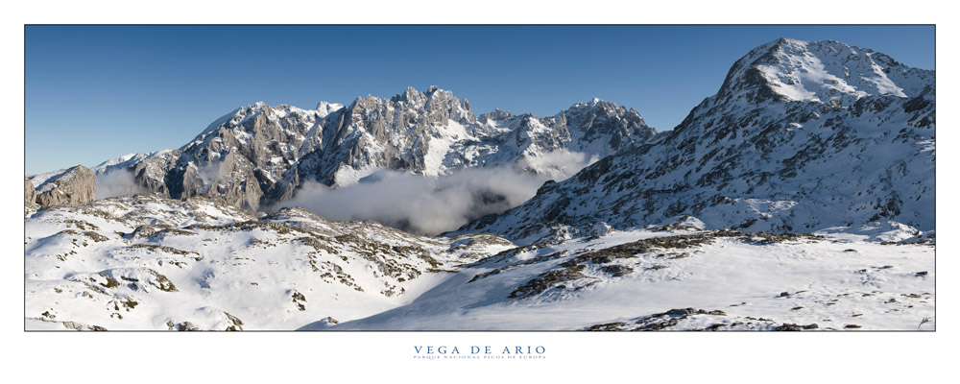

FIGURE 2. Example of figure in double column (if the foot of figure is shorter than the width of the figure will justify to Center).

